

Cairo University Faculty of Computers and Information Department of artificial intelligence

**€-₩on**

**Supervised by**

**Dr. Mohamed A. Wahby**

**TA. Nada Ibrahim**

Implemented by

|  |  |  |
| --- | --- | --- |
| 1 | Ahmed Kadry | 20180018 |
| 2 | Loai Gamal | 20180206 |
| 3 | Mohamed Sayed | 20180224 |
| 4 | Marina Moheb | 20180208 |
| 5 | Marwan Yasser | 20180270 |

Graduation Project

Academic Year 2021-2022

**Abstract**

There is a lot of ways to invest your money one of them is currency trading its profitable but risky and need too much analysis. We are building a software that will help the trader to low this risk and will keep eyes on the market instead of the trader using AI and Data science. This software will make decisions and trade to maximize the profit and minimize the risk to let the traders enter the forex market safely with the lowest human effort in investing money

|  |  |
| --- | --- |
| 1. **Introduction**    * 1. **What is Currency trading**      2. **What is Forex trading**      3. **Why to trade in Forex market**      4. **Problems that some forex traders fall into**      5. **human limitations in forex trading**      6. **Our idea** | 4  4  4  6  7  8  8 |
| 1. **Market and Research**    1. **Challenges a Forex Market Faces**    2. **Challenges our Forex App Faces** | 10  10  11 |
| 1. **Data Collection** | 14 |
| 1. **EDA**    1. **what is EDA?**    2. **EDA on our data**    3. **Trending Lines**    4. **Reversal Patterns** | 17  18  22  25 |
| 1. **Features Engineering** | 29 |
| 1. **Model Evaluation**    1. **Recurrent neural networks:**       * 1. **The advantage of RNNs**         2. **The disadvantage of RNNs**    2. **Proposed model** | 32  32  34 |
| 1. **Conclusion of model evaluation**     1. Intro to LSTM    2. The advantage of LSTM and GRU    3. Proposed model | 38  38  38  39 |
| 1. **Project Phases: Until Now** | 40 |
| 1. **Project Phases: Upcoming** | 41 |
| 1. **References** | 42 |

INTRODUCTION

What is Currency trading:

In its simplest form, if you travel internationally, you might already have engaged in currency trading.

It is the concept of buying a currency with another currency or selling a currency in exchange with another one.

Currency trading is often referred to as Foreign Exchange or **Forex**, it is the buying and selling of currencies in the foreign exchange market with the objective of **making Profits** and it is also referred to as Forex Trading.

What is Forex trading:

Forex trading is the largest market in the world with nearly **5** **trillion** dollars traded on a daily basis, it is the market of currency trading with the objective of making profit, the trade happens when buying or selling a currency for another one and it is usually done through brokers.

Currencies appear to the trader as **Pairs** for Ex:

EUR/USD = 1.17457

the euro (EUR) on the **left** is called the **base** currencywhile the US dollar (USD) on the **right** is called the **quote** currency, and the value beside the pair means that each unit of the base currency is equal to 1.17457 units of the quote currency instead of writing

1 EUR = 1.17457 USD, it tells the traders how many units of quote currency they will get for one unit of base currency.

Traders make decision to **buy** if they expect the value of the quote currency to increase let’s say EUR/USD became 1.20149 if the trader **sells** at this point, then the difference that takes place is how the trader makes profit.

In reality there are two values for the pair, buy (**Ask**) price and sell (**Bid**) price, and the difference between them is called **spread** which is the profit of the broker you are dealing with and it is a constant value.

Trading example:

Let’s say that the ask price of the EUR/USD is 1.17478 and you bought at this point $1,000 and you hold onto this trade till the bid price became 1.17501 then you took the decision to sell, then your profit is (1,000 x 1.17501) – (1,000 x 1.17478) = 0.23,

You profit is only 23 cents! does this small profit worth learning strategies and wasting time trading?

That’s when leverage comes in,

In order to make reasonable profits, trader should enter trades with much higher amount of money.

For example, let’s say your leverage which is expressed as ratio is 1:100 and you want to enter a $100,000 position, your broker will set aside $1,000 and now, you are now controlling a $100,000 investment with $1,000

Why to trade in Forex market:

**The ability to go long or short**

Meaning that you can profit when the price goes up or goes down based on your strategy in trading

Long is to expect the price to increase so you buy and wait till the price increases and then sell, and the difference that takes place is you profit.

Short is to expect the price to decrease so you sell and wait till the price decreases and then buy, and the difference that takes place is your profit.

**The market hours**

The forex market is open 24 hours a day, 5 days a week, from 9pm Sunday to 10pm Friday (GMT), due to its different trading sessions (Sydney, Tokyo, London, New York).

**Forex high liquidity**

It is the most liquid market in the world, since there are a large number of buyers and sellers who are looking for trades at any given time each day.

**Leverage**

As explained above, leverage is double-edged sword because it exponentially increases your trade volume so, profit increases as well as risk.

**Market volatility**

Due to high volume of currency trades each day which is billions of dollars every minute, this makes the price movements of some currencies extremely volatile you can potentially reap large profits by speculating on price movements in either direction and it is also considered a double-edged sword since market can quickly turn against you.

**Wide range of currency pairs**

Forex has a 120+ currency pairs

Problems that some forex traders fall into:

one of the reasons that make a trader lose his money quickly beside his knowledge about trading, is **poor risk management**

Some traders specially beginners fall into this trap of calculating their moves based on the profit regardless of the possible loss and doesn’t care much about the concept of ‘More profit, more risk’.

**Not following a trading plan**

Serious traders need to invest time and effort into developing a trading strategy, they have to consider the optimal entry and exit points, risk/reward ratio and best time to trade, based on their knowledge philosophy in trading.

**Unrealistic expectations**

It is very important for beginner traders to understand that forex is not a means to get rich quickly, your profits is based on a strategy that has a probability of loss and on a market that is extremely volatile, so being patient is a key concept for a successful trader

**Getting emotional**

For all traders specially because they are human, they fall into this trap easily by either being **too greedy** wanting to profit more quickly, or being **too afraid** to risk a bit of their money at all

**Assuming they have enough knowledge**

many traders think that they know enough about currency trading so they stick with one or two strategies and they don’t invest time and effort to learn and keep up with new and complex strategies.

human limitations in forex trading:

* They get emotional
* They don’t have all the time to trade (even if it is a full-time job for them)
* They are limited by their knowledge and experience
* They are not good as a computer in calculations
* Not all of them have patience and consistency to trade every day on the long run

Our idea:

Currency Trading is a great field where people make a lot of money but also a lot of people loses money too. Our goal to help traders to invest their money safely with low risks by depending on an AI software that tracks the market and do analysis on the currencies prices to extract useful information from them then takes the decision based on strategies inferred from AI models and techniques that try to get the maximum profit for the trader with lowest risk possible.

We will extract historical data about the prices and analyze it to prepare this data for feature engineering then the data will be trained by a multi-model AI that will extract information about the market and make decision based on this info and trade without any interference from the user.

**Market and Research**

**Challenges a Forex Market Faces**:

* Every single day, more than five trillion dollars exchanges hands in the forex market—that’s more than the New York Stock Exchange. But, as foreign exchange and currency exchange flourishes, many financial executives struggle to manage global payments effectively. Here are the most common forex problems and how you can solve them.
* It’s Time Consuming:
* The Problem: If you’ve dealt with forex for some time, you know that it can be a long and laborious process. Managing international payments manually requires an exponential amount of time and resources. Different countries have multiple procedures when it comes to sending and receiving funds across borders, and keeping track of all these processes requires a significant amount of bandwidth.
* It’s Difficult to Track:
* The Problem: With forex trading, payments are coming from different locations around the world, not just the United States. It’s time-consuming to track all of these accounts manually, especially as your business grows.
* There’s Too Much Risk
* The Problem: There are various factors that can influence the foreign exchange rate, including global markets and currency volatility. As a financial executive, you need to prepare for all outcomes associated with foreign exchange and currency risk, otherwise, you could lose a significant amount of time and money. For many businesses, this means hiring additional staff in order to manage high-risk global payables effectively. But what if your finance team is a lean operation? And hiring more headcount isn’t an option?
* **Forex management in 2019 and beyond is going increasingly digital, and if you want to improve compliance, enhance cash flow, reduce costs in your organization, and contribute to the bottom line.**
* This is one of the reasons why we are implementing this project due to its global economic importance.

**Challenges our Forex App Faces:**

* The applications that are already in the market:
* The Problem: What are the applications that are already in the market, what do they offer, and what will we offer?
* We will see now best forex trading app in the market:

Best Forex Trading App:

* eToro: is an Israeli social trading and multi-asset brokerage company that focuses on providing financial and copy trading services such as forex and crypto. It has registered offices in Cyprus, the United Kingdom, the United States, and Australia. In 2018, the company's value was $800 million which tripled to $2.5 billion in 2020.

Advantages:

* Trade major Forex pairs for **as low as 1 pip**
* Access **flexible leverage** and **nearly unlimited liquidity**
* Diversify your portfolio with over **40 global FX pairs**
* Know that your funds are safe on our **multi regulated** platform
* 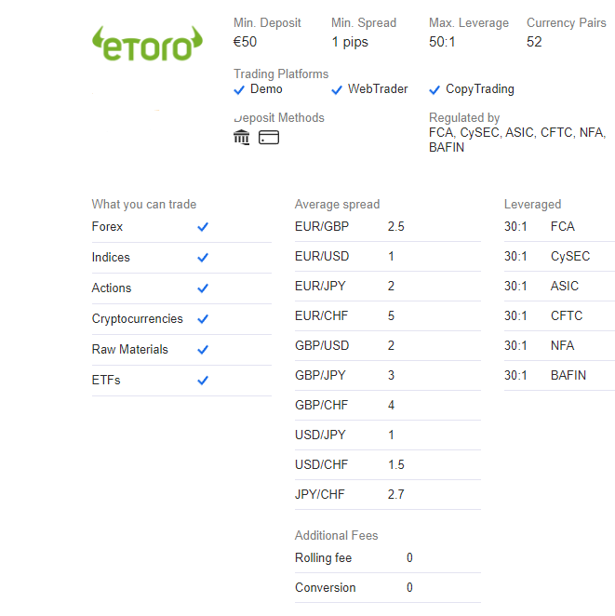Gain insights and **trading ideas** from a community of **10M users**
* Forex Fury: a group of Forex traders with one mission: **make a winning robot**. After years of development, we have achieved our goal. We now have to aim higher. We want to share the work we’ve done and accrue resources so that we can make the software even more effective. I hope that you join us on our mission to create the best trading system to ever hit the market. We know what we have in Fury is profitable and believe we can make all our clients successful regardless of skill level.

-Robot Features:

Compatible with NFA, FIFO, MT4 and MT5 Build 600+

Tested and Proven SET Files (always new settings in development)

Low, Medium & High-Risk Strategies

ECN Support

Effective Money Management to Ensure Sustainable Growth

Trade Any Pair, Indices, or Crypto

Works With Any MT4/MT5 Trading Brokerage

Multiple Filters to Avoid Bad Market Conditions

Easy 5 Minute Installation with Full Guides and Videos

* The Solution:

**We want to be different from all these apps through**

We want to build an app that uses data science and machine learning to trade in forex market that searches the market and take the action that guarantee the profit and minimize the risk.

This app aims to let people invest their money in forex trading ignoring the Presence of trading knowledge Building a user-friendly GUI that provides the customers a dashboard that is easy to understand.

**Data Collection**

Meta Trader the most popular forex trading platform provides an option to extract the prices of a chosen symbol in a specific date range with a specific timeframe (daily, monthly, hourly ,6hours, etc.) and create a csv file with the data of the prices extracted.

* So, we get our data by dates we need or live updated from metatrader5 library in python we can choose any timeframe of the prices and any currency pairs:

import MetaTrader5 as mt5

import datetime

import pytz

import pandas as pd

mt5.initialize()

def live ():

#Set the time zone

timezone = pytz.timezone('ETC/UTC')

#Set the date we want to get the datafrom

from_date = datetime.datetime(2012, 1, 1, 0,0,0,tzinfo=timezone)

to_date =datetime.datetime(2022,3,2,0,0,0, tzinfo=timezone)

#Create the dataframe

df = pd.DataFrame(mt5.copy_rates_range ('EURUSD', mt5.TIMEFRAME_H1, from_date,to_date))

df['time'] = pd.to_datetime(df['time'], unit='s')

print(df.columns)

df.to_excel('data_hourly.xlsx')

live ()

* Then, it exported to me a file with accurate data as in screen: 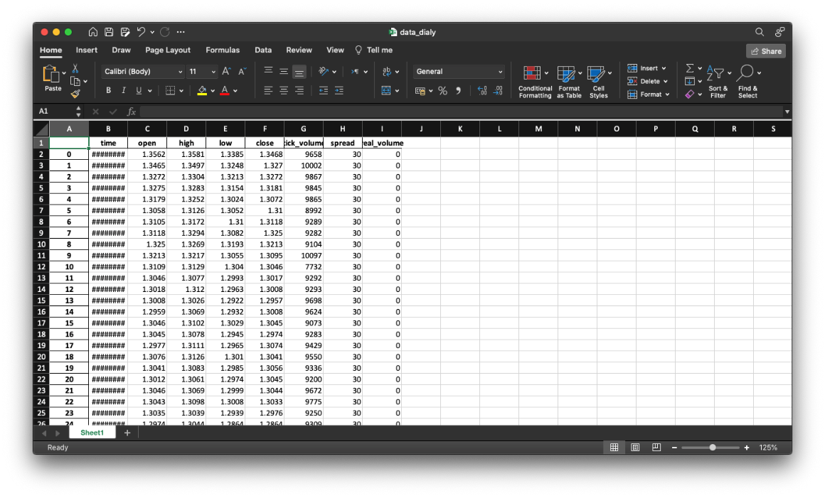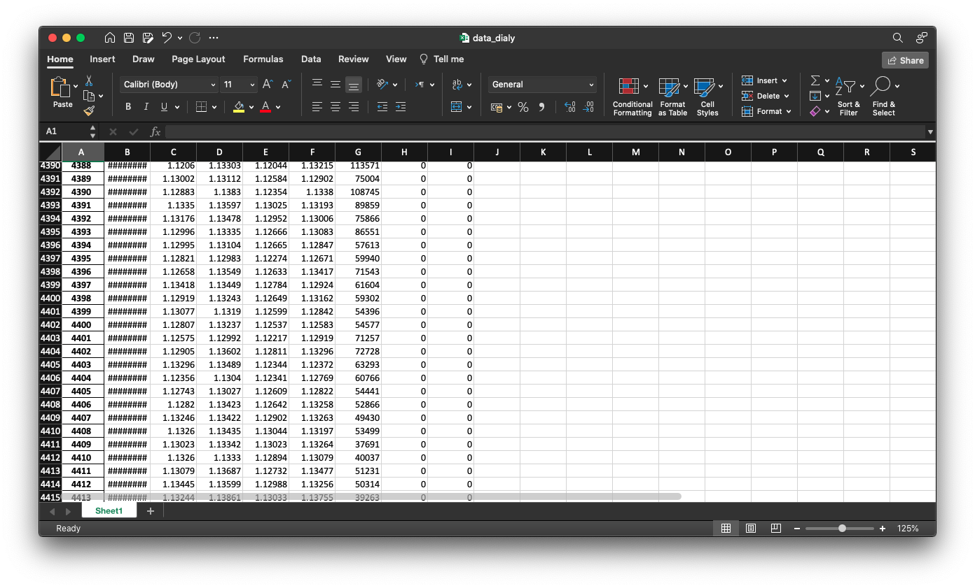
* Features of data are:
* Open: the price of the currency pair that this timeframe starts with. For example, if the timeframe of the data is daily then the open price is the price of the pair at the start of the day
* High: the highest price the currency pair reached during the timeframe
* Low: the lowest price the currency pair reached during the timeframe
* Close: the price of the currency pair that this timeframe ends with. For example, if the timeframe of the data is daily then the close price is the price of the pair at the end of the day
* Tick Volume: the number of trades that happened during this timeframe
* Spread: the difference between the ask and bid prices
* Real Volume: the total volume of the market

**EDA**

**What is EDA?**

* + Exploratory Data Analysis refers to the critical process of performing initial investigations on data to discover patterns, to spot anomalies, to test hypothesis and to check assumptions with the help of summary statistics and graphical representations.
  + It is a good practice to understand the data first and try to gather as many insights as possible from it.

**EDA on our data:**

1. **Support and resistance lines**

* Support occurs when falling prices stop, change direction, and begin to rise.
* Chart

  Description automatically generatedResistance is a price level where rising prices stop, change direction, and begin to fall.

def support(df1, l, n1, n2):

for i in range(l-n1+1, l+1):

if(df1.low[i]>df1.low[i-1]):

return 0

for i in range(l+1,l+n2+1):

if(df1.low[i]<df1.low[i-1]):

return 0

return 1

def resistance(df1, l, n1, n2):

for i in range(l-n1+1, l+1):

if(df1.high[i]<df1.high[i-1]):

return 0

for i in range(l+1,l+n2+1):

if(df1.high[i]>df1.high[i-1]):

return 0

return 1

* **Chart

  Description automatically generated**Support and resistance lines on monthly candles:
* From last picture we concluded that the price is decreasing from Jan 2021 till now and we can say that it is difficult to be decreased less than (1.06355) because it is the last support line.
* **Chart

  Description automatically generated**Support and resistance lines on weekly candles:
* As we see here that the price is decreased less than the support line, but we can say that it is impossible to break the support line of the monthly candles.
* **Graphical user interface, chart

  Description automatically generated**Support and resistance lines on daily candles:
* As we see here that the price is decreased less than the support line, but there is no new support line because the price is still decreasing, and we can say that it is impossible to break the support line of the monthly candles.
* **Chart, line chart

  Description automatically generated**All support and resistance lines on daily candles:

1. **Trending lines:**
   * A trend is when prices move in a zigzag fashion but still follow an imaginary path or a trend in one direction.
   * A picture containing text, windmill

     Description automatically generatedTrend lines connect significant lows in an uptrend, and they connect significant highs in a downtrend, creating dynamic resistance.

def pipeline(df):

global breakpoint_up,breakpoint_down

df_len = len(df)

df['Number'] = np.arange(df_len)+1

df_high = df.copy()

df_low = df.copy()

df.head()

while len(df_high)>2:

slope, intercept, r_value, p_value, std_err = linregress(x=df_high['Number'], y=df_high['high'])

df_high = df_high.loc[df_high['high'] > slope * df_high['Number'] + intercept]

while len(df_low)>2:

slope, intercept, r_value, p_value, std_err = linregress(x=df_low['Number'], y=df_low['low'])

df_low = df_low.loc[df_low['low'] < slope * df_low['Number'] + intercept]

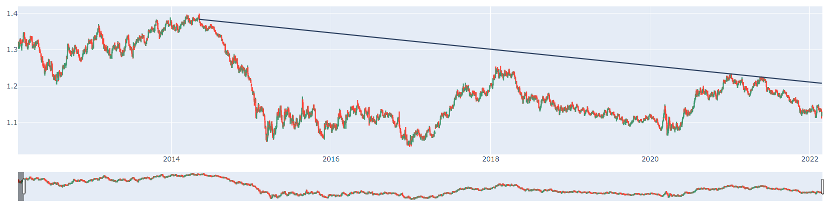

* + downtrend on the daily candles from may 2014 till now this trend isn’t broken
  + 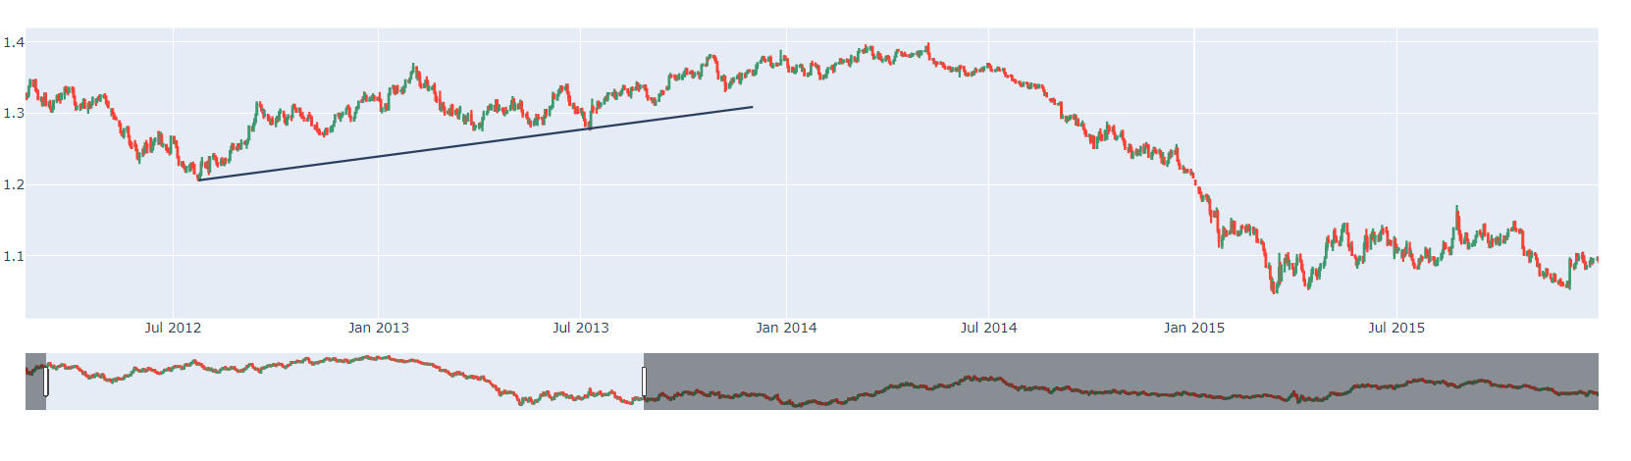But before this current downtrend for EURUSD prices there was an uptrend that continued for about 2 years then the prices start to drop.

**3.Reversal patterns**

* + But how to get from the graph when the prices will actually reverse. There is more than one reversal patterns that we can detect from it the reverse in prices, but we will use the head and shoulder techniques.
  + This is the pattern which the prices are reversed after.
  + 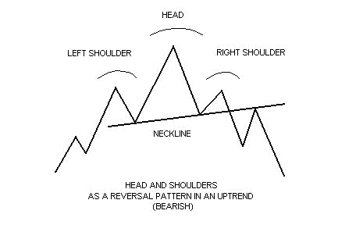On the daily candles we from 2012 tell 2022 the head and shoulder pattern happened 4 times where the prices reversed after it in 2014 the prices drops very deep after this pattern and in 2018 the prices raised after the pattern

def find_patterns(max_min):

max_min=max_min.reset_index()

patterns = defaultdict(list)

# Window range is 5 units

for i in range(5, len(max_min)):

window = max_min.iloc[i-5:i]

# Pattern must play out in less than n units

if window.index[-1] - window.index[0] > 100:

continue

a, b, c, d, e = window['close'].iloc[0:5]

# IHS

if a<b and c<a and c<e and c<d and e<d and abs(b-d)<=np.mean([b,d])*0.02:

patterns['IHS'].append((window.index[0], window.index[-1]))

return patterns

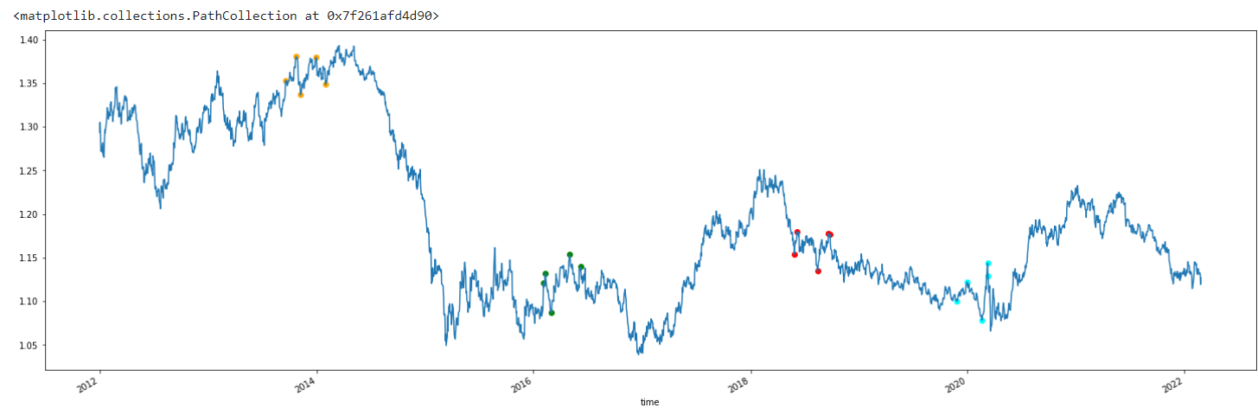

**4.Market volatility:**

* We will analyze tick volume to detect the market volatility and it appeared that at the start of the market time zone there is low tick volume which means high volatility

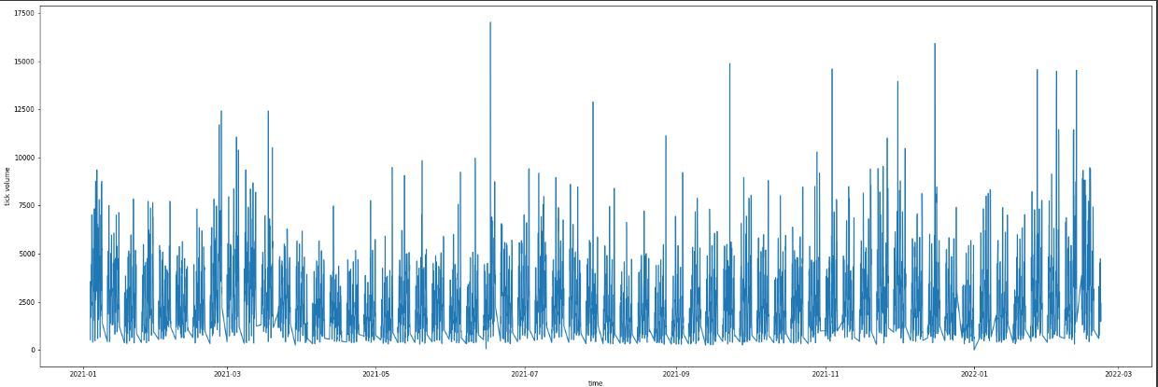

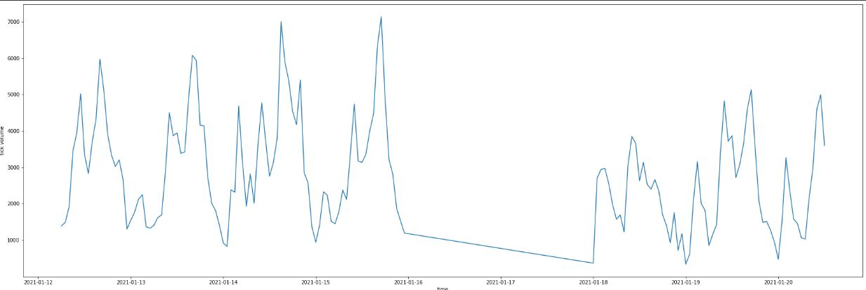

**5.Conculsion:**

* + From this data analysis we found that is important for the AI model to get the following
    1. Know whether we are close to a resistance or support points or not
    2. There is a trend or not and how strong is this trend (from the slope line)
    3. If there is a reversal pattern or not and in which direction (the prices will fall or raise)
  + We will work on training the model to detect these 3 major points which let us know exactly in which direction the prices will go up or down.
  + We will update the features of the prices data to contain this important information

**Feature Engineering**

Now it is time to transform our data so that it becomes consumable by models.

This is the most important point in data science and AI workflow.

* Our data contain 7 main features which are high, low, open, close, tick volume, spread and real volume.
* Real volume most of the time is zero because the brokers not always calculate the real volume despite its importance in the market volatility but we will depend on the tick volume instead of it to detect the market volatility
* The spread almost the same in most of the candles due to using the same broker and we will not be using in training our model despite its importance in market volatility.

So first we will drop the real volume and the spread

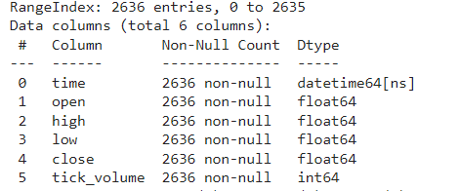

Now we have columns with 0 null values in all of them.

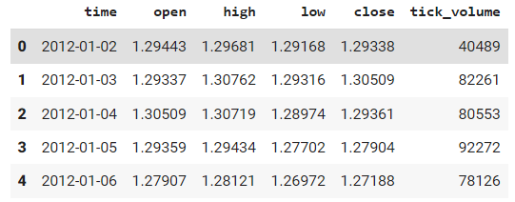

* Now we need to detect the trends in the data so first we need to pick 2 high or low points at least to draw the trendline on them after we calculated the 2 points now, we take those 2 points in both uptrend and downtrend calculation using the slope of the line

df['Uptrend'] = slope * df.index + intercept

df[Downtrend] = slope * df.index + intercept

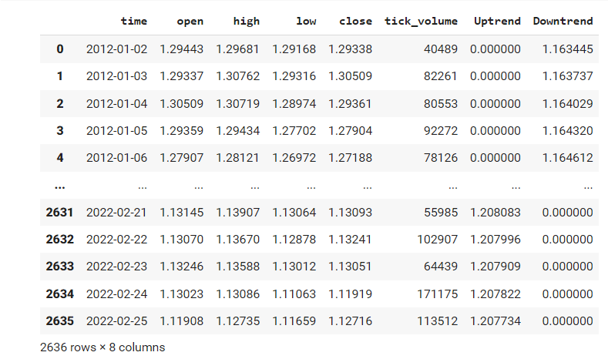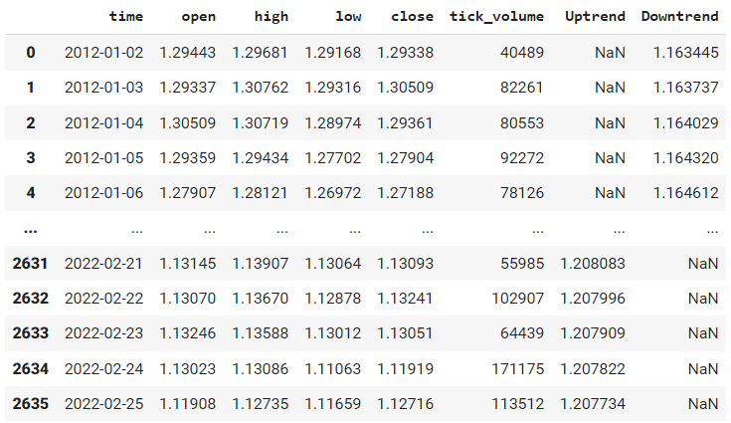

The question is why there is regions that have null values in the uptrend but a value in the downtrend and vice versa. That because it's impossible to have a downtrend and an uptrend at the same time so that’s why when there is a value in the uptrend of course there is a null value in the downtrend.

* Now let’s replace the null values to 0 to be usable by our models.
* 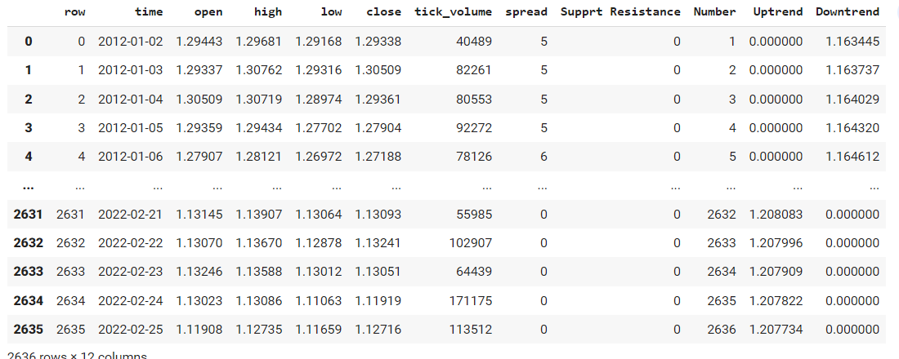We need to detect the support and resistance points and add this feature to our data 1 is support –1 is resistance 0 is neither both.

That is the final features we will use in our model that contains the most important information about the data.

**Model Evaluation**

-We Found that we need AI techniques that depends on Time series data like RNN models and its derivatives as LSTM and GRU

**1-Recurrent neural networks:**

[Recurrent neural networks](https://www.sciencedirect.com/topics/engineering/recurrent-neural-network) are a class of [neural networks](https://www.sciencedirect.com/topics/computer-science/neural-networks) that are naturally suited to processing time-series data and other sequential data.

**About RNNs:**

RNNs as an extension to [feedforward networks](https://www.sciencedirect.com/topics/computer-science/feedforward-network), in order to allow the processing of variable-length (or even infinite-length) sequences, and some of the most popular recurrent architectures in use, including long short-term memory (LSTM)

RNN is a [neural network](https://www.sciencedirect.com/topics/computer-science/neural-networks) designed for analyzing streams of data by means of hidden units. In some of the applications like text processing and speech recognition, the output depends on the previous computations.

RNN is the second kind of [ANN](https://www.sciencedirect.com/topics/engineering/artificial-neural-network) model, in which the outputs from neurons are used as feedback to the neurons of the previous layer. In other words, the current output is considered as an input for the next output.

**The advantage of RNNs:**

They have a significant representation for keeping the information about the past time steps. The output produced at time t1 affects the parameter available at time t+11. In this manner, RNNs keep two kinds of input such as the present one and the past recent one to produce the output for the new data.

**The disadvantage of RNNs:**

They face the vanishing gradient problem which makes RNN unable to capture the long-term dependency and information for the sequential data.

**Solutions to vanishing gradient problem:**

**1-LSTM:**

Long short term memory is an extension of the RNN models.

That deals with vanishing gradient descent problem buy introducing new gates such as input , forget gate and output gate which allow for a better control over the gradient flow and enable better preservation of “long range dependencies”

**2-GRU:**

Gated recurrence units are newer generation of RNNs and it is pretty similar to LSTM.

GRUs get rid of the cell state and use the hidden state to transfer information it is also has two gates , reset gate and an update gate

LSTM and GRU in forex market:

We found a lot of researches that deal with the forex market prediction using the LSTM or GRU or a hybrid model using both. They produce a good results like predicting the prices or predicting the trends.

OUR introduced model:

* We have developed a hybrid model that has a GRU at the front layer and LSTM at the back. We applied our purpose model to predict the closing price of EURUSD currency pair we have predicted the forex prices for 10 minutes before the actual time.
* For getting a better relation between the data and for getting better training results we have to add some additional attributes to our data set. These attributes are: Hour, Day, Week, Momentum, Average price, Range, and OHLC price. The attributes are calculated from the original dataset.
* Our proposed hybrid model is built using four layers, where the first layer contains GRU with 20 hidden neurons and the second layer contains LSTM with 256 hidden neurons. The third layer and fourth layers are dense layers with 64 and 1 hidden neurons respectively. We have trained his model using the 10 minutes

input_layer=keras.Input(shape=(8,1))

gru_layer=layers.GRU(20,return_sequences=True)(input_layer)

lstm_layer=layers.LSTM(256)(gru_layer)

dense_layer=layers.Dense(64,activation='relu')(lstm_layer)

output_layer=layers.Dense(1,activation='relu')(dense_layer)

model=keras.Model(input_layer,output_layer)

* The percentage of training data and test- ing data are 80% and 20% respectively

y=x['close']

x=x.drop(['close'],axis=1)

x_train,x_test,y_train,y_test=x[:int(len(x)*0.8)],x[int(len(x)*0.8)+1:],y[:int(len(x)*0.8)],y[int(len(x)*0.8)+1:]

date=x_test['time']

x_train['time']=x_train['time'].astype(int)

x_test['time']=x_test['time'].astype(int)

x_train,y_train,x_test,y_test=np.array(x_train),np.array(y_train),np.array(x_test),np.array(y_test)

* Validation is an important step that is used to check the performance of the system by comparing actual data with predicted data. Here we have MSE(Mean Squared Error)

model.compile("adamaloss='MeanSquaredError')

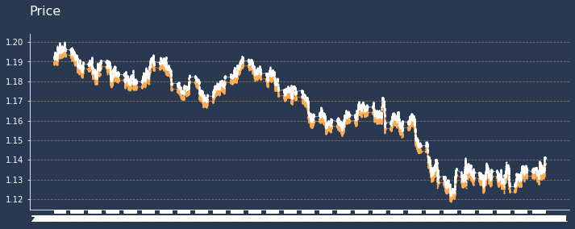

* Then , we will also consider CNN for further predictions and Reinforcement learning for Decision making

**Conclusion of model evaluation**

At the end of our research, we concluded that with this data we need a model with time series domain and with more search we found that the suitable one is RNN model with some changes to skip the disadvantage of RNN model and this changes called LSTM model and GRU model.

**The disadvantage of RNNs:**

They face the vanishing gradient problem which makes RNN unable to capture the long-term dependency and information for the sequential data.

**Introduction about Long Short-Term Memory (LSTM):**

* It is a variation of RNN to solve the vanishing gradient problem.
* The LSTM-based RNN is applied in this section to process the sequential trajectory data and generate a future prediction.
* Hochreiter and Schmidhuber developed the LSTM cell to overcome the drawbacks of RNN

**The advantage of LSTM:**

* This network has more benefits than traditional RNNs because they can maintain long term interrelations and nonlinear dynamics in the case of a time series input data set. Specifically, in RNN or [LSTM](https://www.sciencedirect.com/topics/engineering/long-short-term-memory), the same weight is maintained across all layers which control the number of parameters the network requires to learn.
* The LSTM-RNN solves the long-term dependency problem by introducing three extra gates, known as the input gate, forget gate, and output gate. The gates cooperate to control the information flow. The chain-like LSTM RNN model replaces the hidden states with the LSTM cell.

**Project Phases: Until Now**



**Project Phases: Upcoming**



**References**

1. <https://www.forexbrokers.com/guides/forex-trading-apps>
2. <https://www.ig.com/en/forex?chid=12&cx_aid=37768&cx_us=ECXDQWBj9CuyCbFg5tDnr5oUfkqm6EyLfU07Dzp::&cx_pg=leveraged&cx_cid=9545>
3. <https://www.managementstudyguide.com/advantages-and-disadvantages-of-forex-market.htm>
4. <https://www.ig.com/en/forex/benefits-of-forex-trading>
5. <https://www.babypips.com/tools/forex-market-hours>
6. <https://admiralmarkets.com/education/articles/trading-psychology/top-reasons-why-forex-traders-fail-and-lose-money>
7. <https://www.sciencedirect.com/science/article/pii/B9780128161760000260>
8. <https://www.sciencedirect.com/topics/engineering/recurrent-neural-network>
9. <https://www.sciencedirect.com/topics/engineering/long-short-term-memory>